PRACTICAL -10
Aim:
To write a program to implement Kruskal’s Algorithm for finding the Minimum Spanning Tree of a graph.
Theory:
A Minimum Spanning Tree (MST) of a connected, undirected, weighted graph is a spanning tree that connects all the vertices using exactly V – 1 edges with the smallest possible total edge weight. MSTs are widely used in network design, such as laying cables, pipelines or roads at minimum cost.
Kruskal’s Algorithm is a greedy algorithm that builds the MST by considering edges in increasing order of weight. It starts with every vertex as its own separate component and repeatedly adds the cheapest edge that does not create a cycle. For each edge (u, v), there are two cases:
- u and v are in different components: the edge is added to the MST and the two components are merged.
- u and v are already in the same component: adding the edge would form a cycle, so it is rejected.
To detect cycles efficiently, the algorithm uses the Disjoint Set Union (Union-Find) data structure with path compression and union by rank, which makes each find/union operation almost constant time. The running time is dominated by sorting the edges, giving O(E log E), which is the same as O(E log V). Unlike Prim’s algorithm, which grows a single tree, Kruskal’s algorithm grows a forest of trees that gradually merge into one.
Algorithm:
- Input the number of vertices and the list of edges (u, v, weight).
- Sort all the edges in non-decreasing order of weight.
- Create a disjoint set with each vertex in its own set; initialize an empty MST edge list and total cost = 0.
- For each edge (u, v, w) in the sorted order:
  - Find the roots (representatives) of u and v.
  - If the roots are different, add the edge to the MST, add w to the total cost, and union the two sets.
  - If the roots are the same, discard the edge as it would form a cycle.
- Stop when the MST contains V – 1 edges.
- Display the MST edges and the total cost.
Program Code:
class DisjointSet:
def __init__(self, n):
self.parent = list(range(n))
self.rank = [0] * n

def find(self, x):
# path compression
if self.parent[x] != x:
self.parent[x] = self.find(self.parent[x])
return self.parent[x]

def union(self, x, y):
root_x, root_y = self.find(x), self.find(y)
if root_x == root_y:
return False # same set -> adding edge forms a cycle
# union by rank
if self.rank[root_x] < self.rank[root_y]:
root_x, root_y = root_y, root_x
self.parent[root_y] = root_x
if self.rank[root_x] == self.rank[root_y]:
self.rank[root_x] += 1
return True

def kruskal(n, edges):
# sort all edges by weight
edges = sorted(edges, key=lambda e: e[2])
ds = DisjointSet(n)
mst_edges = []
total_cost = 0

for u, v, w in edges:
if ds.union(u, v):
mst_edges.append((u, v, w))
total_cost += w
if len(mst_edges) == n - 1:
break
return mst_edges, total_cost

# Demo
if __name__ == "__main__":
n = 6
edges = [(0, 1, 4), (0, 2, 4), (1, 2, 2), (1, 3, 5),
(2, 3, 8), (2, 4, 10), (3, 4, 2), (3, 5, 6), (4, 5, 3)]

mst, cost = kruskal(n, edges)
print("Edges in the Minimum Spanning Tree:")
for u, v, w in mst:
print(u, "-", v, ": weight", w)
print("Total cost of MST:", cost)

Output:
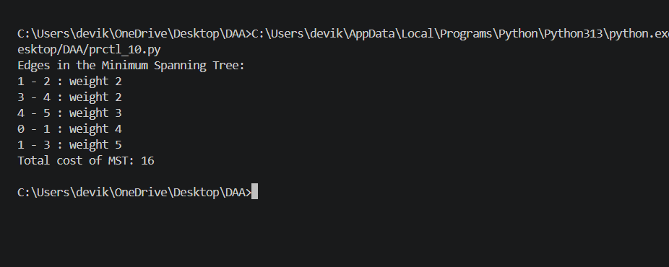

Result:
The program successfully implements Kruskal’s Algorithm. By sorting the edges and using the Union-Find data structure to reject edges that form cycles, it produces a Minimum Spanning Tree of 5 edges with a total cost of 16 for the given graph, running in O(E log E) time.

